INFOSYS 321 - Peer Evaluation

Your Details:
Group Number | 62
Name | Charles Tiriamai
UPI | Ctir836
AUID | 5263125

Question 1:
Do you think that all members of your group equally contributed to the report submitted? Please remember that this is about the process (e.g. general overall effort, enthusiasm, and commitment) rather than about who contributed exactly what to your completed assignment report.

No

Question 2:
You have 10 points for each person in your team (40 in total for a group of 4). You must allocate all of these points based on each individual’s contribution to the assignment.

If you feel that each team member has contributed equally to the assignment, you should allocate 10 points to each person.

If you feel that a team member has contributed more to the assignment, then you should allocate more than 10 points to that person.

If you feel that a team member has contributed less to the assignment, then you should allocate less than 10 points to that person.

Group Member’s Name | Contribution
Charles Tiriamai | 19
Donghyeong Woo | 19
Decun Zhang | 2
Iqmal Shamsul Bahari | 0

Question 3:
If you have not given each person 10 points, please explain why. Include relevant details and screenshots. You must provide a valid justification for each person you have not given 10 points.

Donghyeong and I contributed the majority of the work to the assignment. Decun made a minor contribution to section 1, but was not present at all during section 2. Iqmal made very little attempt to contact any of the group, was not present for any of the group meetings, and did not help with either section of the assignment.

There was minor contact with Decun during the project work phase. He attended the first meeting (on Thursday, October 12th), but it took place before he was able to attend his lab (which was the next day, on Friday), and was thusly unable to provide much input, so we agreed to meet again, the next day, after his lab, if we were free. Then he would have had the same amount of experience/knowledge concerning SAP that we had from our lab time. Donghyeong and I continued to work for a couple of hours after Decun had left.

Friday came, Donghyeong and I stayed to work on the assignment, but Decun was unable to attend the meeting because of another assignment he had due, so he said he would think about section 1 over the weekend, and contribute what he could. Nothing was added over the weekend. Donghyeong and I continued to work for a few hours after Decun had left.

Monday came, and Decun, Donghyeong, and I attended our Monday lab stream to finish section 1. Although Decun was present, he contributed only to a small part of the assignment, namely, a discussion about the second business process for the second scenario, which is reflected in one of the screenshots below which shows the changing versions of our group document. He was also asked to review the stuff already done to see if he thought any changes needed to be made, but none were noted. Decun pasted a URL that we discussed and used to justify our chosen process, then, once again left before Decun and I, although this time he did not leave a substantial amount of time before us, and what he mentioned in the discussion was useful.

There were no further group meetings. Donghyeong and I talked about the assignment while we were working on section 2, but there was no contact from Decun or Iqmal. We finished what we could of section 2, then handed it in. Decun messaged later that night, saying that he'd forgotten about the due date.
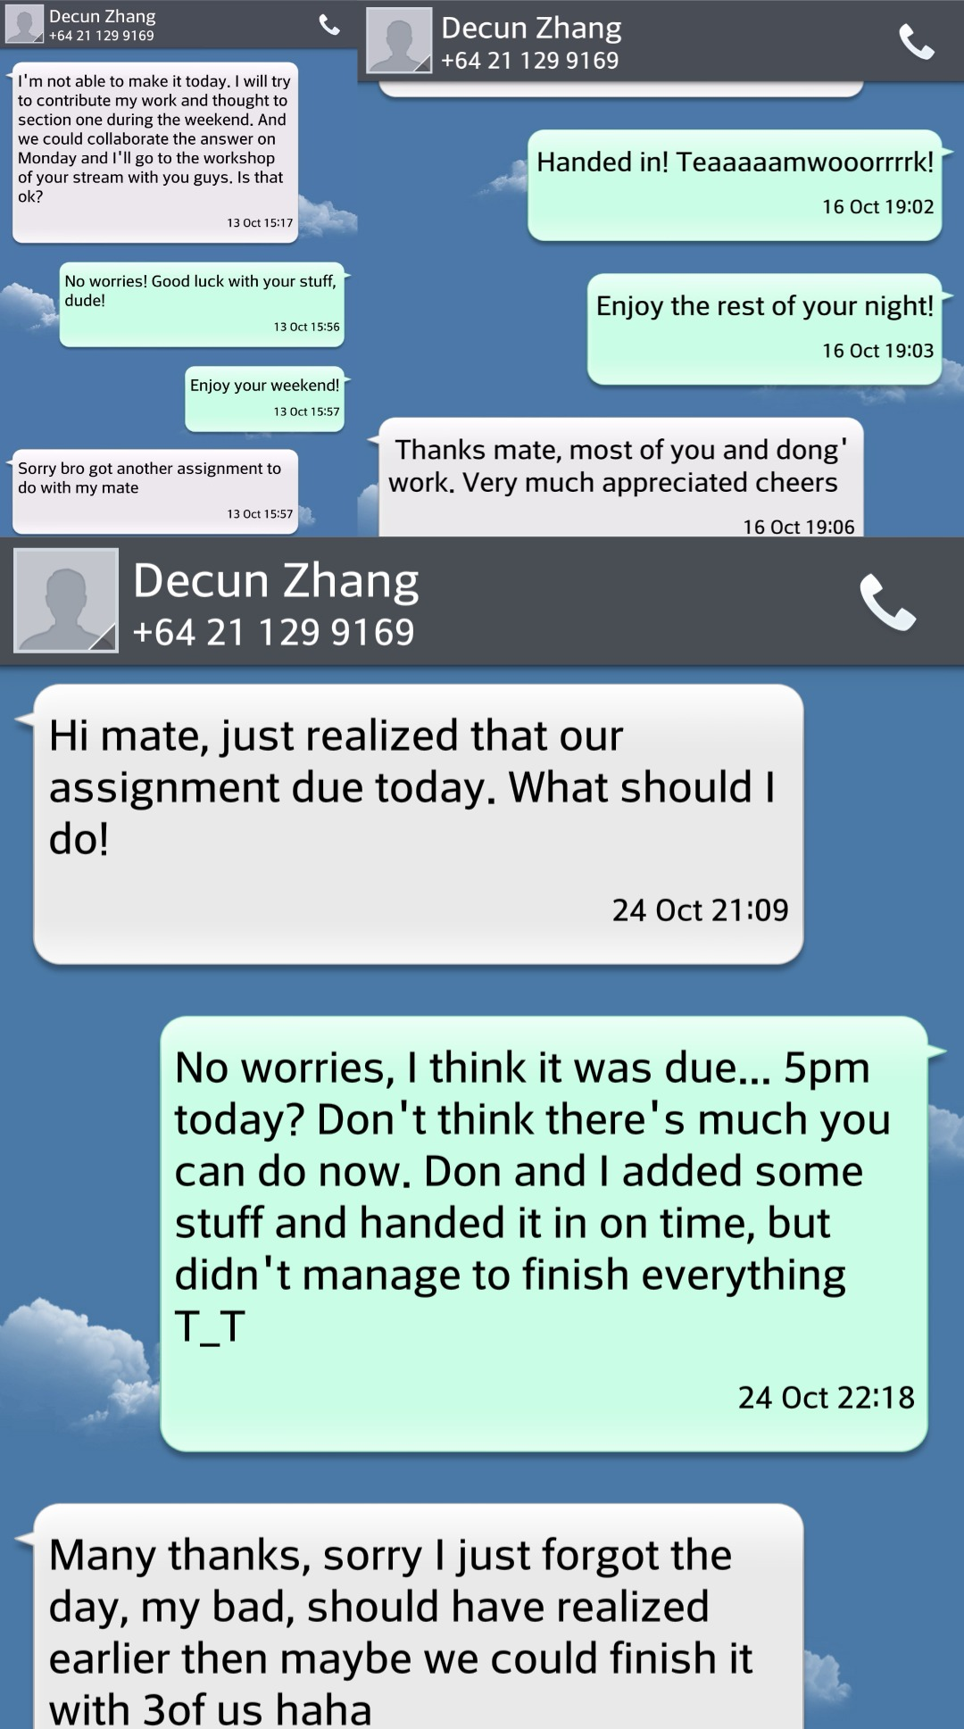

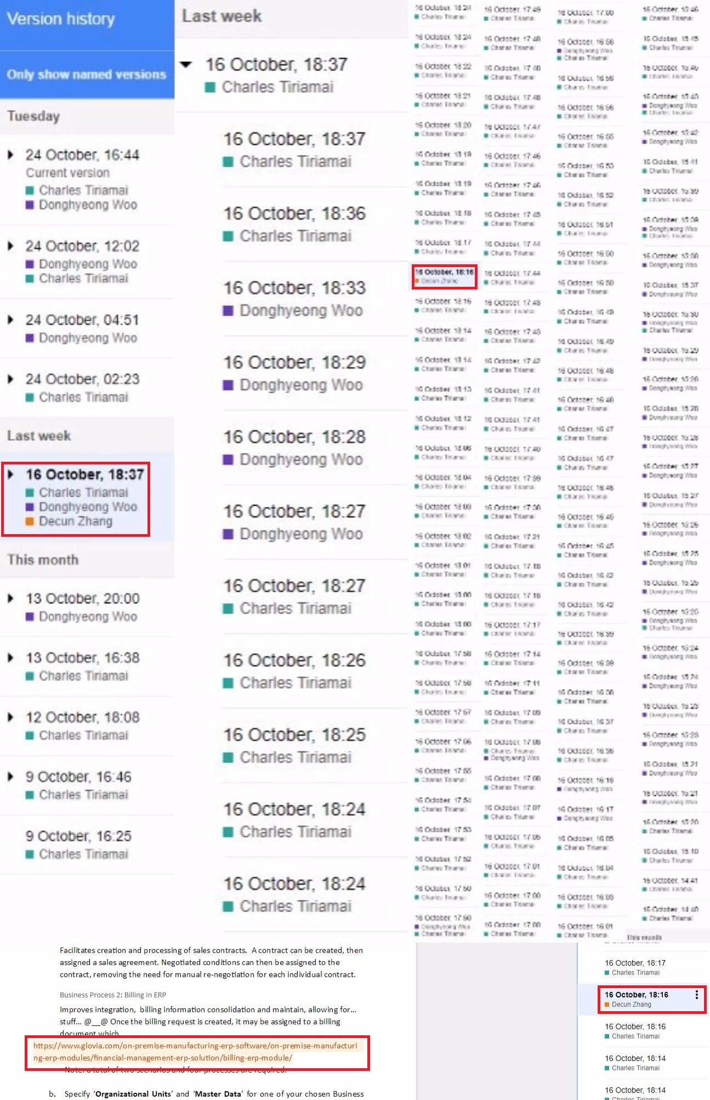
Iqmal posted that he'd been having trouble with his internet, but didn't meet us or contact us outside of his initial messages, shown here, or stating his absence of internet.
